**Dragon:**

* **Placing Towers**
* Scenario: Launched the game, killed enemies to gather enough gold to summon the dragon on the field.
* Result (**EXPECTED**): The dragon can be dragged on the map, has a timer displayed as health bar, can shoot any enemy and has cooldown (that is shown as a circle in the bottom left corner). Also the dragon is dynamic (it can be moved around the map by clicking on a different map location).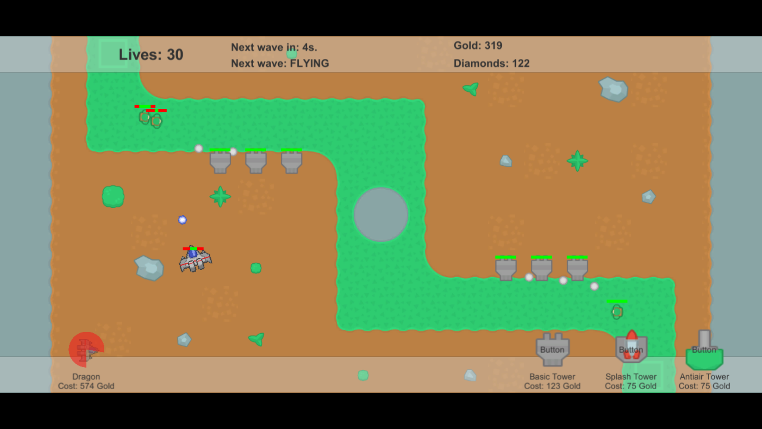

Obs: There has been an incident where the dragon projectiles would not hurt planes, but push them around. The incident has been solved since.

* **Gold, Diamonds & Upgrades**
* Scenario: Launched the game, killed enemies to gather gold and diamonds.
* Result(**EXPECTED**): Each enemt drops gold and diamonds. Gold is used during the match and diamonds are used for upgrades after the match. The upgrade contains upgrade options for the towers and the dragon. For the tower, there are upgrades for range, damage speed. The dragon can be given different auras.

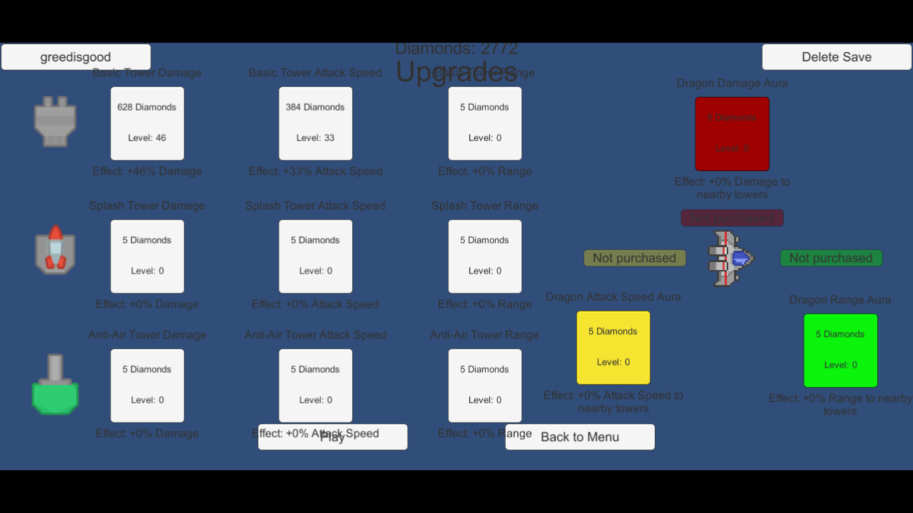

* **Tower destroying enemy**
* Scenario: Launched the game, and played until the tower destroyng enemy spawned.
* Result(**EXPECTED**): The enemy goes to the nearest tower and destroys it.

